

Dharmsinh Desai University, Nadiad

Faculty of Technology, Department of Computer Engineering

B.Tech. CE Semester – VI

Subject: System Design Practice

**Project Title:**

**Online Learning Platform**

**Submitted By:**

Ailani Nikhil CE004 17CEUOS134

Bhadaniya Prizesh CE014 17CEUOG095

Dholariya Hardik CE030 17CEUOF018

**Guided By:**

Prof. Sheetal S. Shah

Assistant Professor, CE Dept.

Dharamsinh Desai UniverSity, Nadiad.



Dharmsinh Desai University, Nadiad

Faculty of Technology, Department of Computer Engineering

**CERTIFICATE**

This is to certify that System Design Practice project entitled “Online Learning Platform” is the bonafied report of work carried out by

1. **Ailani Nikhil CE004 17CEUOS134**

**2) Bhadaniya Prizesh CE014 17CEUOG095**

**3) Dholariya Hardik CE030 17CEUOF018**

Of Department of Computer Engineering, Semester VI, academic year 2019-2020,

Under our supervision and guidance.

|  |  |  |
| --- | --- | --- |
| Guide |  | HOD |
|  |  |  |
| **Prof. Sheetal S. Shah** |  | **Dr. C. K. Bhensdadia** |
| Assistant Professor of |  | Head of the Department of |
| Department of Computer |  | Department of Computer |
| Engineering  Dharmsinh Desai University, Nadiad. |  | Engineering  Dharmsinh Desai University, Nadiad. |

**Content**

1. Abstract...…………………………..…………………..…………………………..……..…….4

2.Introduction……………………………………………………………………….….................5

3. software reqirement specification.…………………..………………………...……..…..…….7

3.1 Types of users………...…………..…………………..……………………………...7

3.2 Funtional requirements………………………………………………….…...............7

3.3 Non functional requirements…………………..………..……………………...……11

4.Design…………………………….…………………..………………………...……………...12

4.1 Usecase diagram……....…………..…………………..……………………….........12

4.2 Class diagram…………………………………………………………….……........13

4.3 Sequence diagram……...………………………..………..…………………..….....14

4.4 Activity diagram…….………...………………………………………….…............15

4.5 State diagram…….………...…………………………….……………….…...........18

4.6 ER Model...………...…………..…………………..…………...…………….….....19

4.7 Data Dictionary……………………………………………………………..............20

5. Implementation Details……………..……...…………..………..………………..……..……23

6. Testing………..…………..………………...…………..………..…………………........…...26

7. Screens shots ………………………..……...…………..………..…………………………...27

8. Conclusion …………………………..……...…………..………..…………………………..30

9. Limitation & future Implementation Details………………...…..…………………..…..…...32

9.1 Limitations……………..…......……………………………………….…................32

9.2 Future implementations…………..….……………..……………………….……..32

10. Bibliography………………….…......………………………………………….……...........33

1. Abstract

Online Learning Platform provides basic education functionality. It provides the platform to student. We basically provide subjects of Computer Engineering. Students have different functionality. Teachers are the mentor for the students. Teachers provide content for student. We try to provide medium with some graphical and video content so students can gain better knowledge of fundamentals.

2. Introduction

Online Learning Platform have different two types of users like students and teachers. Teachers have functionalities like upload content like file and video, upload topics articles, and add test questions for different subjects. Students have functionalities like read the articles, explore video and file content. Student can ask the query of any subject to respective subject teachers. Student can also refer the solutions of the past queries which were asked by another students.

Tools/Technologies

**Technologies:**

HTML 5

CSS 3

Bootstrap 4

Python

Django

DBSqlLite

**Tools:**

Atom

Sublime Text

**Platforms:**

Localhost:8000/ in browser

3. Software Requirement Specifications

**3.1 Types of User**

1. Student

2. Teacher

3. Admin

**3.2 System Functional Requirements**

**R.1: Student**

R.1.1: Login

IP: Provide username & password

OP: Success or invalid message

Process: validation of credentials

R.1.2: Register

IP: Add required information

OP: Successfully registered

R.1.3: Explore subject

Content and Credit of the subject will be provided

IP: Click on any subject

OP: Detailed information of the subject

R.1.4: Refer Articles

System provides different list of articles which is uploaded by teachers

IP: Click on articles

OP: Content will be shown

R.1.5: Explore Videos

IP: Click on the particular subject's video

OP: All video content of the subject

R.1.6: Explore Files

IP: Click on the particular subject content

OP: files of topics will be shown

R.1.7: Attempt Test

Student can attempt mini test of any subject

IP: Answer the Multiple choice question

OP: result of the test

R.1.8: Add Queries

Any doubt can be asked by the student

IP: provide query and subject name

OP: query will be sent to the provided subject's teacher

R.1.9: Explore Feed

Student can also explore solution provided by another queries

IP: just go to feed section

OP: All solution will be provided there

R.1.10: Check profile

IP: Check your profile & may change information

OP: Any changes will be applicable except username

R.1.11: Search topics

IP: enter topic or subject name and serach it

OP: related search output will be displayed

R.1.12: Provide feedback

IP: Contact on our given phone or mail

OP: Your suggestion will be considered by us

**R.2: Teacher**

R.2.1: Login

IP: Provide username & password

OP: Success or invalid message

Process: validation of credentials

R.2.2: Register

IP: Add required information

OP: Successfully registered

R.2.3: choice subject

Teachers can select maximum five subjects of their choice

IP: Select from dropdown at registration time

OP: Registered subject with their profile

R.2.4: Add Articles

Topic and description article can be added by teacher

IP: Attach article with description

OP: Added to the list

R.2.5: Add Videos

IP: Upload video of their own

OP: Student can explore it

R.2.6: Add files content

IP: Upload file content

OP: students can refer it

R.2.7: Add Test

Teachers have to add the test question for student

IP: Add question with options and level of hardness

OP: student can attempt test

R.2.8: Give solution

Solve the queries raised by the students

IP: give appropriate answer of query

OP: all students can refer it

R.2.9: Check profile

IP: Check your profile & may change information

OP: Any changes will be applicable except username

R.2.10: Provide feedback

IP: Contact on our given phone or mail

OP: Your suggestion will be considered by us

**R.3: Admin**

R.3.1: Login

IP: Provide username & password

OP: Success or invalid message

Process: validation of credentials

R.3.2: Show users

IP: show request of users

OP: List of students and teachers

R.3.3: Add subject

Subject will be handled by admin

IP: Added new subject

OP: Added to the subject list

R.3.4: Remove teacher

IP: remove inappropriate teacher

OP: that teacher is no longer part of application

R.3.5: Manage feedback

IP: show the list of feedback provided by users

OP: apply appropriate changes to courses

**3.3 System Non Functional Requirements**

* Database
* Editor like Atom
* Django API
* Gmail server
* Smtp server

4.Design

**4.1 : Use Case Diagram**

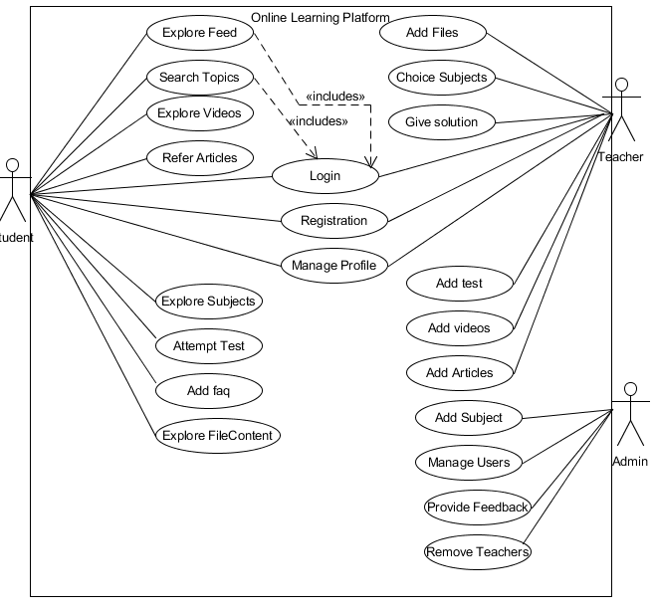

**4.2: Class Diagram**

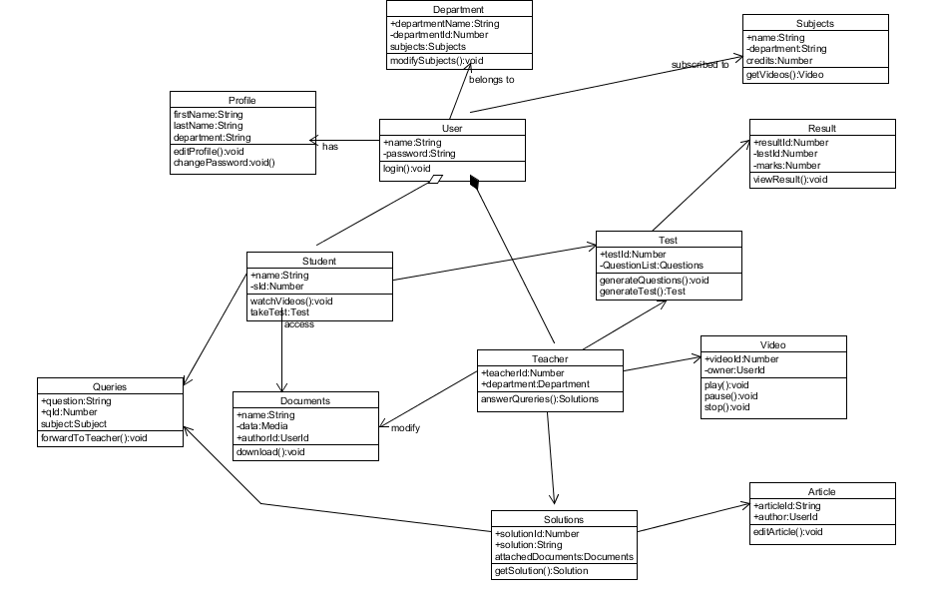

**4.3 : Sequnce Diagram**

**4.3.1: Take the test**

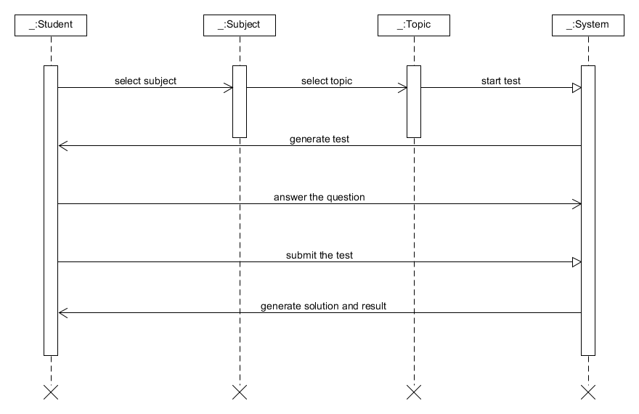

**4.3.2: Upload the content**

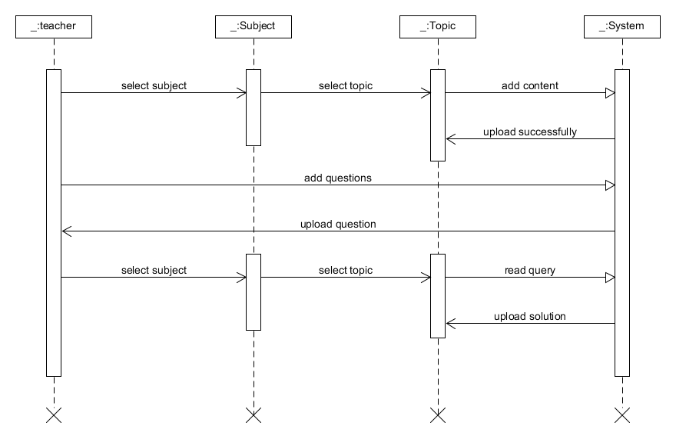

**4.4: Activity Diagram**

**4.4.1: Give the test**

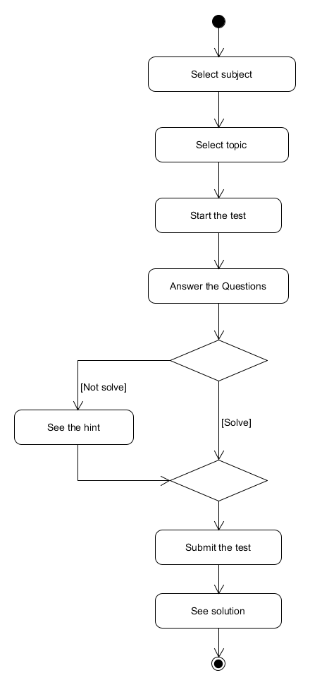

**4.4.2: Upload Content**

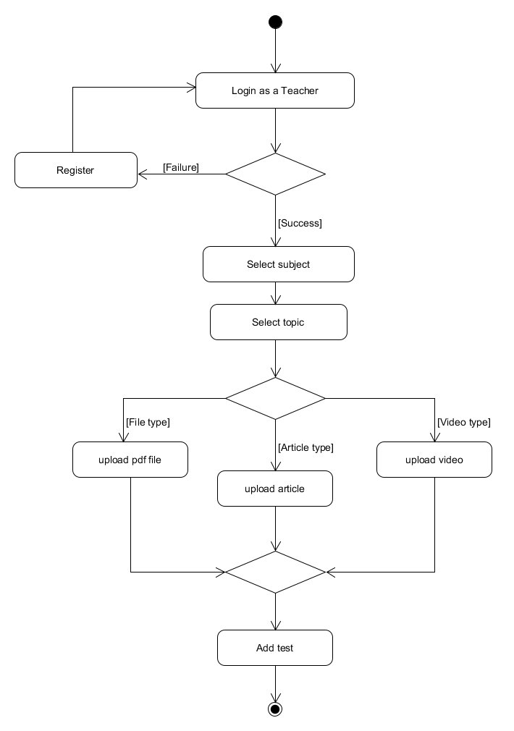

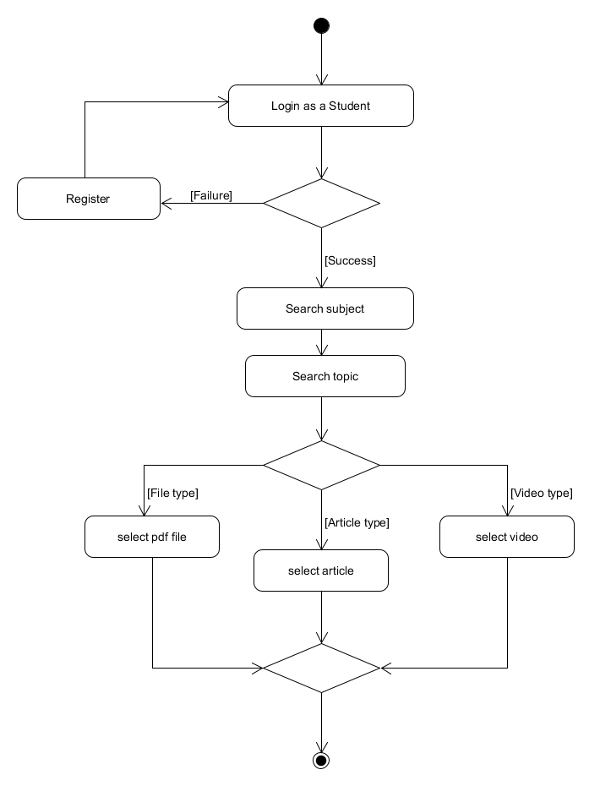**4.4.3: Explore Contents**

**4.5: State Diagram**

**4.5.1: Mail**

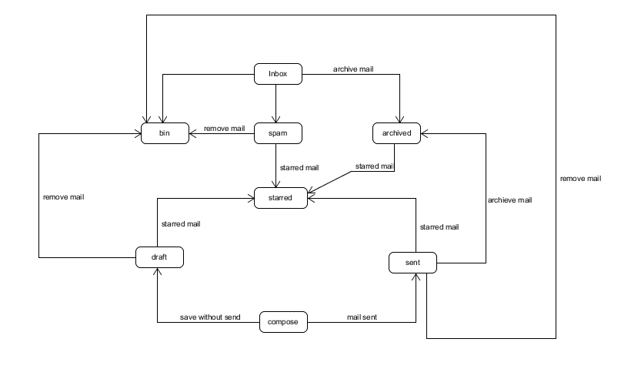

**4.6: ER Diagram**

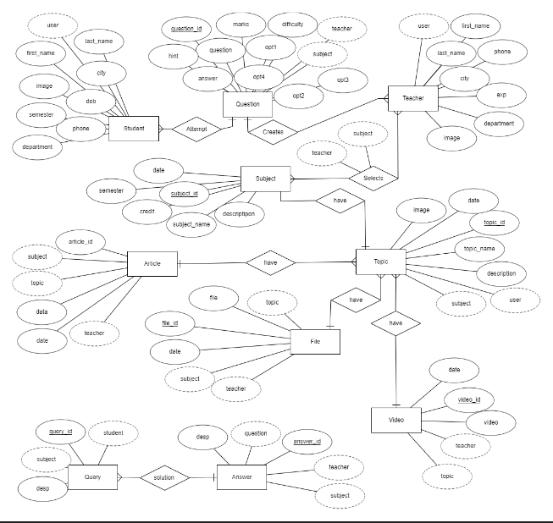

**4.7: Data Dictionary**

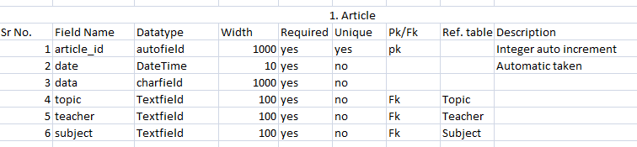

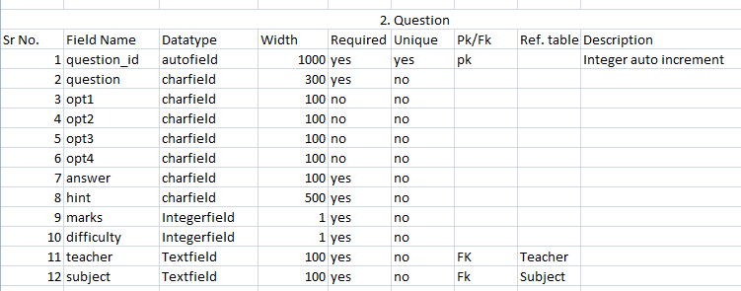

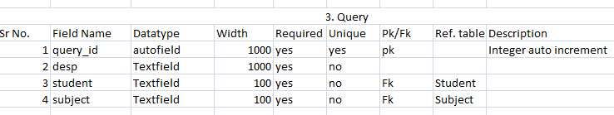

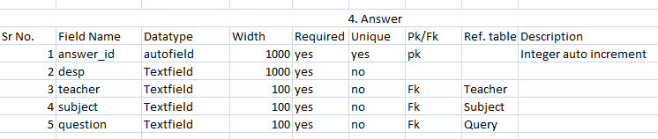

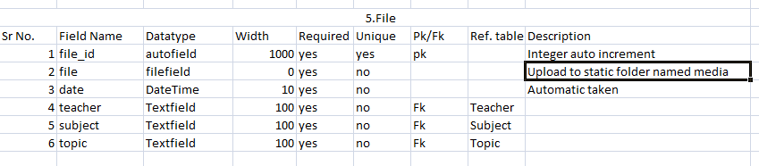

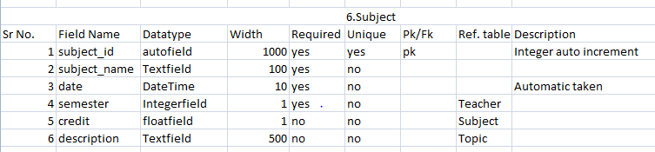

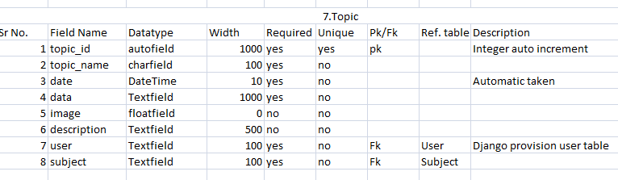

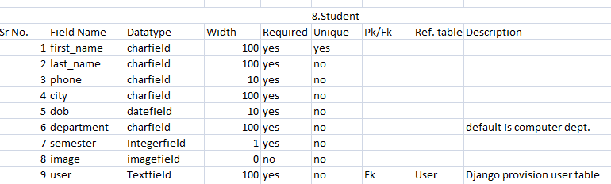

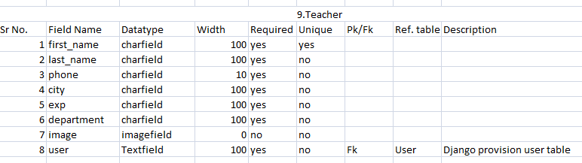

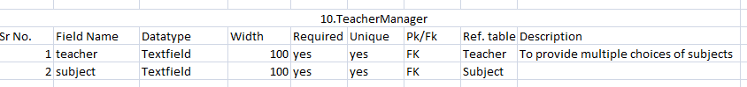

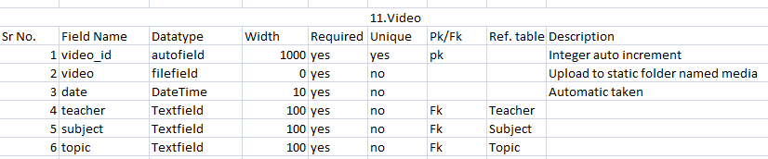

5. Implementation Detail

**5.1: Modules**

* **Articles**

Articles modules provide CRUD operation of the articles. so List of articles is useful for only students and other three operation can be done by teachers.

* **Exam**

Exam module is useful for only teacher which require adding question with options and hardness level.

* **Faq**

Faq module is useful to student by asking the query to teacher and then teacher can answer the query of students.

* **Home**

It is only for the home page and basically no backend logic is there in home module.

* **Material**

Teachers can upload file content using this module and students can view and read the uploaded files by teachers.

* **Media**

Django provides static storage module called media which provides to store items like images, video, file.

* **Result**

Calculations of test results and provide test score to student are done using result module.

* **Subjects**

List of all subjects and brief and detailed description of subjects are provided by it. Topics description of particular subject is provided by this module.

* **Users**

Registration, mail, login and forget password functionality are provided by users’ module.

* **Videos**

Video content are handled by this module.

**5.2: Functions**

* **Login**

It is the basic function for authentication. Login function validates credentials and if it is correct then authorizarization will be performed as per student or teacher.

* **Register**

At first time teacher or students have to register their selves. They have to provide required credentials and then they access the application further.

* **Mail**

After registration successfully mail will be provided and mail is also helpful to send otp in the case of forget password.

* **Verify**

Verify function validate the answer and calculate the result for the student and displays the result. It is located in result module.

* **Answer**

Answer function provide functionality to teachers for giving answer the asked queries and provide solutions.

* **Upload File**

It provides functionality to teacher the upload content in the form of the files.

* **Take**

Take function take the subject name and creates the test for that subject.

* **Upload video**

It provides functionality to teacher the upload content in the form of the video.

* **Show Video**

Students can see the uploaded video content of all subjects.

* **Set**

It is useful to set the new password after forgetting password via mail functionality.

6. Testing

**6.1: Unit Testing**

Python Django provides better way of testing. After combining all application. We can generate web application. Application can be tested using unit testing. We can check models using make migrations and migrate. Django also provides way to alter the field in models.py.

**6.2: Integration Testing**

After combining application web application needed to be tested. Whole web application can be tested after entering the different types of data. Application also tested login as different users like teacher and student. We solved some issues and break of the application.

**6.3: Test Cases**

1. Login as a student

2. Login as a teacher

3. Django Administration

7. Screen shots

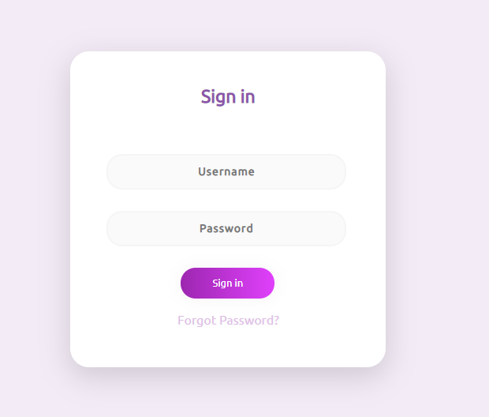

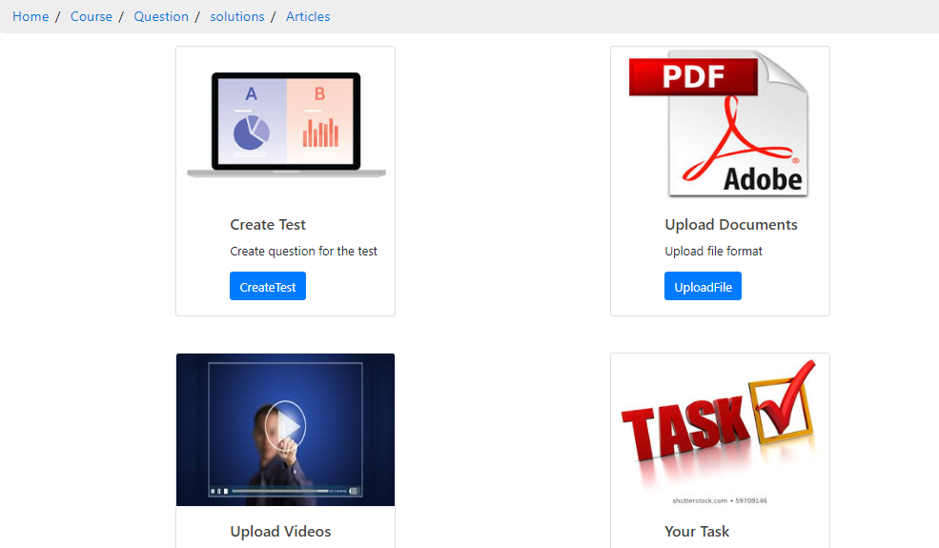

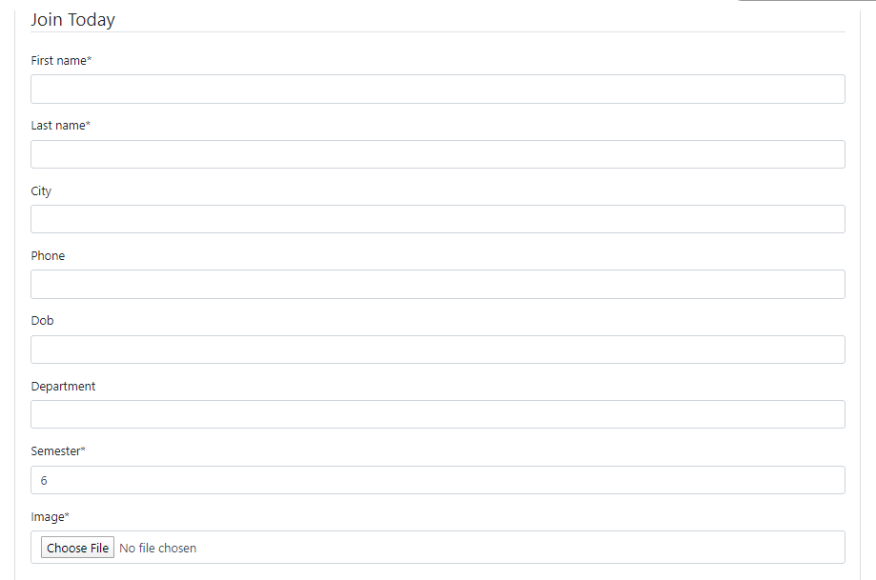

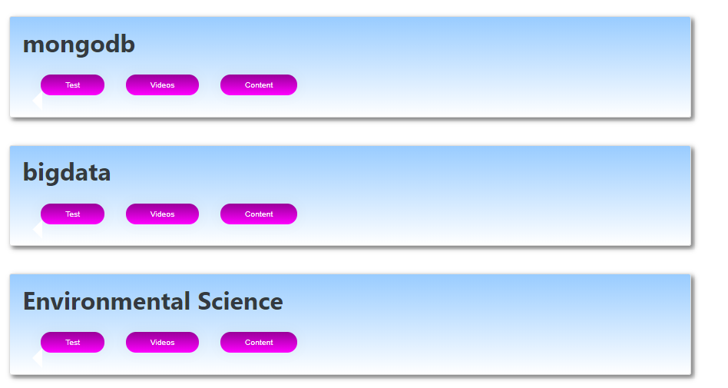

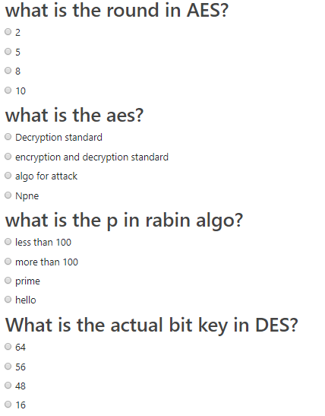

8. Conclusion

Online Learning Platform provides the intermediate role between students and teachers. System will be helpful to better understand basic fundamentals of subjects using graphical and video medium than traditional way of teaching. Student can study at any time anywhere so system provides portability. System provides different functions for different users are as follows:

**8.1: Student’s Functionalities**

* Login
* Register
* Refer Subject
* Refer topics
* Read Articles
* Read File Content
* Show Video Content
* Attempt Test
* Search Articles
* Ask Queries
* Show Feeds
* Give Feedback
* Edit Profile

**8.2: Teacher’s Functionalities**

* Login
* Register
* Subject Selection
* Add Topics
* Add Articles
* Add File Content
* Add Video Content
* Create Test
* Solve Queries
* Give Feedback
* Edit Profile

**8.3: Admin’s Functionalities**

* Login
* Add subject
* Manage users
* Manage feedback
* Remove teachers

9. Limitations and Future Enhancements

**9.1: Limitations:**

We have only implemented for Computer Engineering. We are not implemented different versions and level of tests. We also don’t have the dashboard. We don’t provide the facility of downloading files or video, only reading or watching is allowed. Our application need more amount of data stores on server side so we need to shift our database on server which provides better maintainability and scalability.

**9.2 Future Enhancements:**

* We will extend our application for all courses on the large scale with some Machine Learning.
* We will also allow some more functionality to student like downloading video and files, bookmarks, various versions of tests and notification on new updates at our application. We will also implement the dashboard and progressive graph for students. We will provide different types of level in education and tests. Some of the above functionalities will be paid and basic functionality will be provided as free.
* We will hire best tutor for our application. We will also pay salary to them. We will provide some to do tasks to faculties. Tutors have to make an assignment, personal attention on students. Different versions of tests also will be implemented by the tutor and analysis of student’s process report also done by our application.

10. Reference / Bibliography

* Following links and websites were referred during the development of this project.
* <https://www.google.co.in>
* <http://www.getbootstrap.com>
* <http://www.w3schools.com>
* <http://www.stackoverflow.com>
* <https://docs.djangoproject.com/en/3.0/>
* <https://github.com/search?q=corey+schafer>